4015
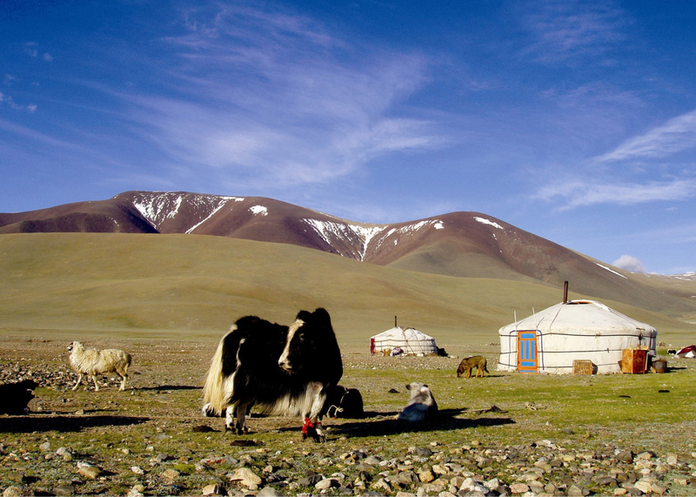

identifier
005e88dd-c9af-48ec-9e4b-c45fbe5ca086

creator
Boldbaatar, Yu.

type
Image

coverage
Mongolia

description
Livestock near a herder

publisher

source
https://ich.unesco.org/img/photo/src/4015.jpg

rights

subject

date
2010

language

original filename
04015.jpg

extent
1.5 MiB
1688x1204 px

format
image/jpeg

modified
2012-12-05 02:28:26

