Noogii and Enkhee branding camels
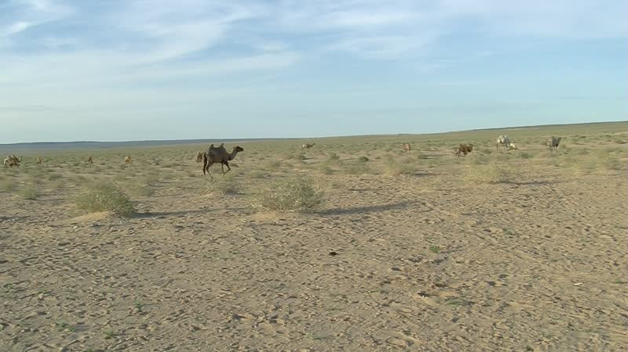

identifier
01f710b7-40f1-4994-94be-16696789d9a4

creator
Thrift, Eric

type
Moving Image

coverage
Mongolia
Dornogovi aimag
Sainshand sum

description
The recordings in this series depict Noogii and Enkhee branding young camels at their summer camp, next to Khamar Monastery.

publisher

source

rights

subject
Pastoralism Videos
Branding Camels
Noogii-Enkhee

date
2012-07-04

language

format
inode/directory

modified
2018-03-02 09:37:44

original filename
PastoralismVideos--2012-07-04--BrandingCamels--Noogii-Enkhee--Dornogovi-Sainshand.vclips

table of contents
time | clip | description
0:00:00 | 300G0023 01 | The two nephews carry a tub of dung over to where the camels are to be branded. Noogii comes over and tries lighting it. He takes out some of the dung and places it in a pile, then asks his nephew to take the rest of the dung away. Noogii sprinkles some gasoline on the dung pile, as the other nephew arrives carrying the branding iron. Noogii lights the fire as the two boys watch, then places in the branding iron in the fire to heat it up. He goes over to where the camels are standing as a group, and grabs one by a rope around its neck. Enkhee arrives and leads the camel to where the branding iron has been left. Running a rope around the camel's legs, as Enkhee holds the rope from the camel's neck, Noogii causes the camel to fall over. His nephew helps to hold the camel down as Noogii retrieves the branding iron and brands the camel.
0:13:53 | 300G0023 02 | Noogii continues to brand the camels. He leads a camel and topples it, with the help of the two nephews, then brands the animal. He repeats this with a second camel, then rebuilds the fire and goes back to the camels.
0:27:47 | 300G0023 03 | With some effort, Noogii catches and brands another camel, then goes off to lasso another one.
0:41:40 | 300G0023 04 | Noogii and Enkhee continue branding the camels. Two visitors show up, and watch as Noogii brands two camels.
0:55:34 | 300G0023 05 | Nootii, Enkhee, and their nephew continue roping camels. The nephew ropes one first, then Noogii ropes two. They bring the three camels over to be branded.
1:09:28 | 300G0023 06 | The two visitors help hold down two camels as Noogii brands them. The older visitor rebuilds the fire. Enkhee ropes a camel but then loses it, and chases after it unsuccessfully.
1:23:21 | 300G0023 07 | Noogii brands several more camels, then waits for the branding iron to heat up again.
1:37:15 | 300G0023 08 | Noogii brands the last of the camels.

