Professor Bulag's Mongolian study: my "nation", your "problem"
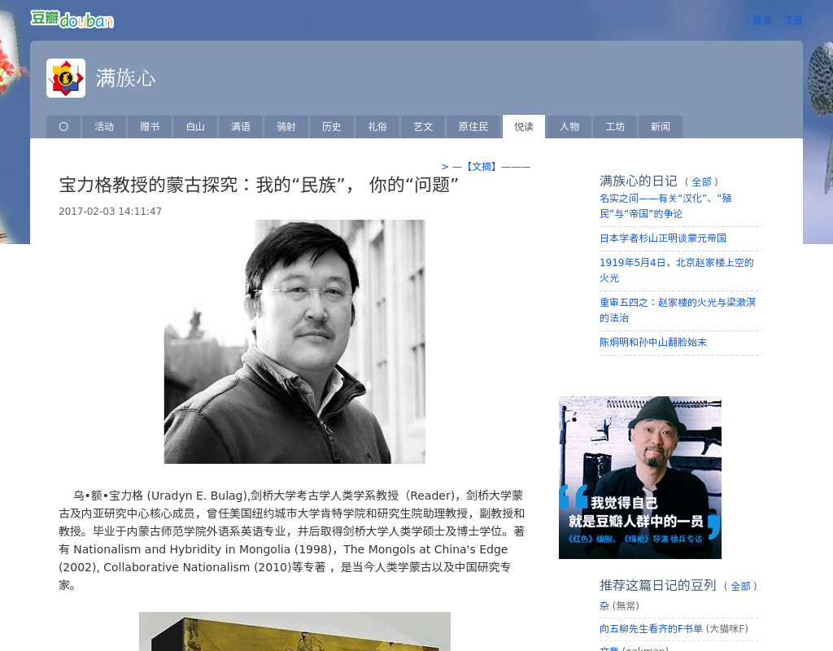

identifier
05ecec4a-e53a-4322-bd4f-7690f6b1e538

creator
Bulag, Uradyn E

type
Text

coverage
Inner Mongolia
PRC

description
Interview with Uradyn Bulag by two Chinese students, on the topic of nationalism and Mongols in China.

publisher
Manchu Heart (blog)

source
https://site.douban.com/125457/widget/notes/10742746/note/604719500/

rights

subject
ethnicity
nationalism

date
2017-02-03

language
Chinese

extent
69.0B

format
text/plain

contributor
Gao Chan
Wang Ningxin

relation
5be1851a-9ee5-4113-9aae-9114da1746c2

original_filename
2016-interview.url

public

