Haymaking in Dornogovi
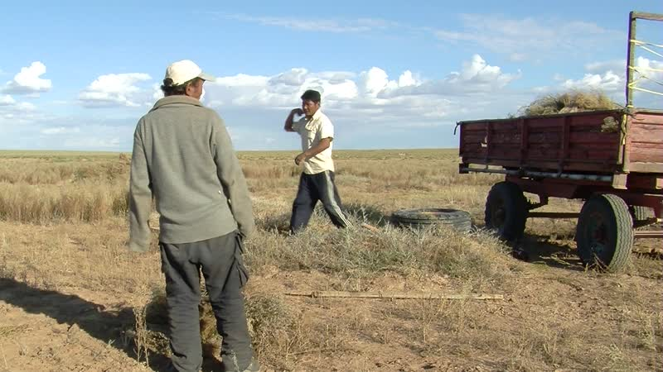

identifier
065ce171-8f3f-4cda-9510-242f68285ccd

creator
Thrift, Eric

type
Moving Image

coverage
Mongolia
Dornogovi aimag

description
This series of audiovisual recordings documents manual haymaking by Gantömör, Jargal, San, and Okhüü. Although there are not any tall grasses to be found in the Gobi, the herders manage to gather two truckloads of vegetation using sickles and pitchforks.

publisher

source

rights

subject
Pastoralism Videos
Hay Making
Gantomor-Jargal

date
2012-09-14

language

modified
2018-01-18 09:40:16

table of contents
time | clip | description
0:00:00 | 300G0177 01 | Remains of a socialist-era drilled well, near San's camp.
0:02:43 | 300G0178 01
0:16:36 | 300G0178 02
0:27:28 | 300G0178 03
0:41:21 | 300G0178 04
0:55:15 | 300G0178 05
1:05:14 | 300G0179 01
1:19:08 | 300G0179 02
1:33:02 | 300G0179 03

