Ovoo worship at Sümiin Bulag ovoo, Dornogovi
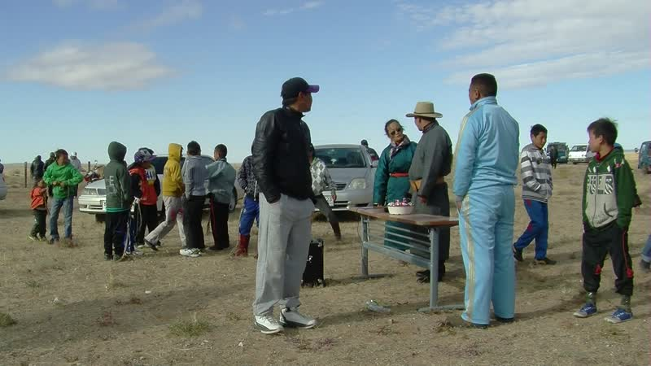

identifier
14059922-ae7b-4450-ad0d-bb09f938ef1a

creator
Thrift, Eric

type
Moving Image

coverage
Mongolia
Dornogovi aimag
Örgön sum

description
This series of audiovisual recordings documents the annual ovoo worship (ovoo takhikh) ritual at Sümiin Bulag in Örgön sum, Dornogovi aimag. This sacred site is the location of a natural spring and the ruins of a former temple, as well as several ceremonial cairns (ovoo). Families from this area worship the sacred site on the 15th day of the middle month of autumn, according to the traditional lunisolar calendar. We joined Dösh Lama, his wife, and Gündsamba from Khamar Monastery in attending the ritual. Beginning at sunrise the men climbed the hills one at a time, carrying a platter of meat offerings prepared from each household, and sat as Dösh Lama chanted eulogies to the mountain next to each ovoo. Meanwhile the women sprinkled offerings of milk in the direction of each ovoo from below. Finally everyone circumambulated the stupa next to the spring. Once the worship was complete, everyone shared their offerings with the other families. The ovoo worship was followed by a feast, then horse races and wrestling among local herders.

publisher

source

rights

subject
Pastoralism Videos
Ovoo Worship
Sumiin Bulag

date
2012-10-02

language

format
inode/directory

modified
2018-01-18 15:23:46

original filename
PastoralismVideos--2012-10-02--OvooWorship--SumiinBulag--Dornogovi-Orgon.vclips

table of contents
time | clip | description
0:00:00 | 300G0205 01
0:00:42 | 300G0206 01
0:01:54 | 300G0207 01
0:15:48 | 300G0207 02
0:19:43 | 300G0208 01
0:33:36 | 300G0208 02
0:45:28 | 300G0209 01
0:57:08 | 300G0210 01
0:59:52 | 300G0211 01
1:06:54 | 300G0212 01
1:12:05 | 300G0213 01
1:17:27 | 300G0214 01
1:18:34 | 300G0215 01
1:22:24 | 300G0216 01
1:22:50 | 300G0217 01
1:23:10 | 300G0218 01
1:23:22 | 300G0219 01
1:23:35 | 300G0221 01
1:25:24 | 300G0222 01
1:28:07 | 300G0223 01
1:36:03 | 300G0224 01
1:38:27 | 300G0225 01
1:41:31 | 300G0226 01
1:42:19 | 300G0235 01
1:42:26 | 300G0236 01
1:56:19 | 300G0236 02
1:57:49 | 300G0236 03
2:00:21 | 300G0237 01
2:14:15 | 300G0237 02
2:15:38 | 300G0238 01
2:24:53 | 300G0239 01
2:24:59 | 300G0241 01
2:27:48 | 300G0242 01
2:41:42 | 300G0242 02

