Tour of the livestock feed cultivation area at Delger Farm, Dornogovi
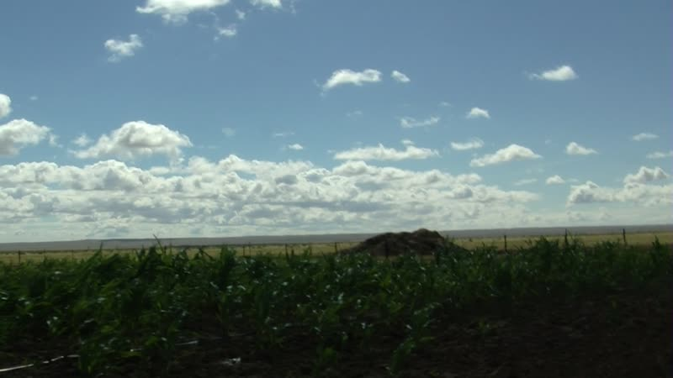

identifier
1716a112-62bd-40ed-95a7-a8fe2d3d595a

creator
Thrift, Eric

type
Moving Image

coverage
Mongolia
Dornogovi aimag
Sainshand sum

description
These recordings present a brief tour of the livestock feed cultivation area at Delger Farm. Delgersaikhan explains that this year's crop will be smaller than he had hoped, and points out that the rows of corn planted by outside labourers have failed to grow. Delgersaikhan shows some photographs of hay production taken with his mobile telephone.

publisher

source

rights

subject
Pastoralism Videos
Delger Farm

date
2012-09-13

language

format
inode/directory

modified
2018-01-18 13:53:37

original filename
PastoralismVideos--2012-09-13--DelgerFarm--Dornogovi-Sainshand.vclips

table of contents
time | clip | description
0:00:00 | 300G0166 01
0:13:53 | 300G0166 02

