Preserving khömüül (wild onions) and milling tsulikhir at Khamar Monastery
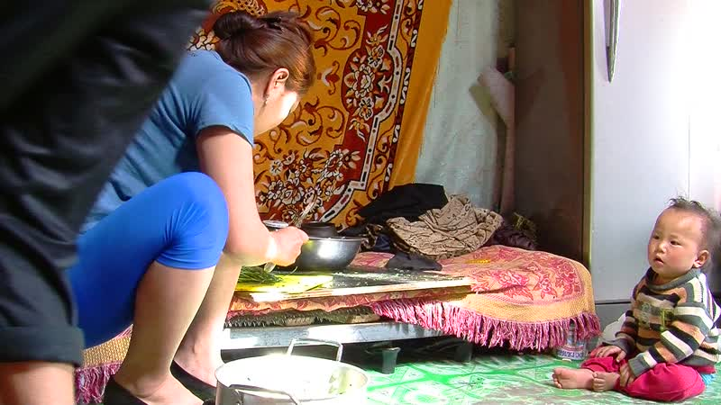

identifier
27bf3d8e-d79a-4928-b179-3eec92b68ed6

creator
Thrift, Eric

type
Moving Image

coverage
Mongolia

description
Dolgor and Nar-Od chop wild onions, which will preserved in jars with plenty of salt. Meanwhile Dolgor's sister Khükhenee mills tsulikhir using a mortar and pestle.

publisher

source

rights

subject
Pastoralism Videos
Preserving Wild Onions
Milling Tsulikhir
Dolgor
Khamar Monastery

date
2012-05-11

language

format
inode/directory

modified
2018-03-02 09:37:44

original filename
PastoralismVideos--2012-05-11--PreservingWildOnions--MillingTsulikhir--Dolgor--KhamarMonastery.vclips

table of contents
time | clip | description
0:00:00 | 244 0329 01
0:13:54 | 244 0329 02
0:27:48 | 244 0329 03
0:31:38 | 244 0330 01

