Caroline Humphrey - Buryatia photos - No. 3-06
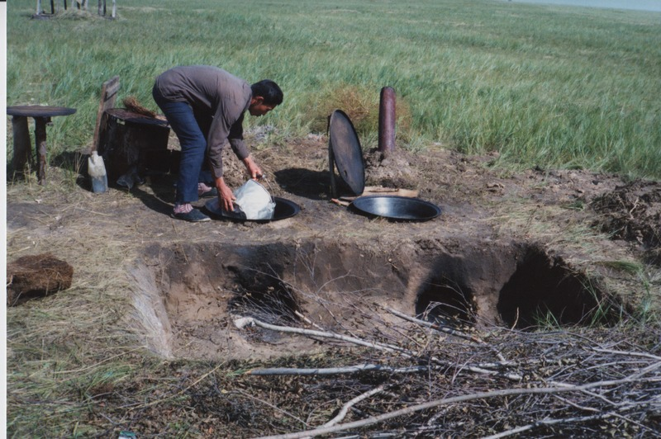

identifier
2b9d58bd-7ef0-4021-94e0-8bf208989d3f

creator
Humphrey, Caroline

type
Image

coverage
Khargant

description
Outdoor cooking stove.

publisher

source
Scanned from a print held in the archives of the Mongolia and Inner Asia Studies Unit, University of Cambridge.

rights

subject

date
1993

language

contributor

original filename
Humphrey-Buryatia-photos-3-06.png

relation

extent
3.9MiB
1799x1196 px

format
image/png

