Caroline Humphrey - Buryatia photos - No. 4-02
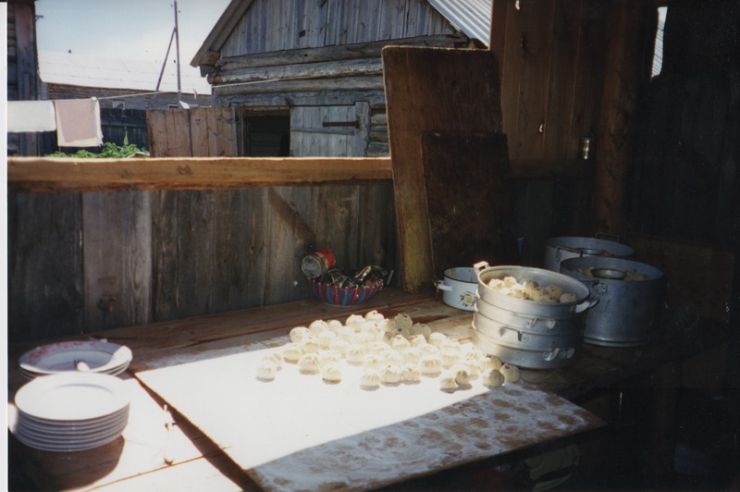

identifier
2dde1746-c9e0-4751-9297-550030eb86ad

creator
Humphrey, Caroline

type
Image

coverage
Uro
Bayangol
Buryatia
USSR

description
Wedding preparations -- *buuz*

publisher

source
Scanned from a print held in the archives of the Mongolia and Inner Asia Studies Unit, University of Cambridge.

rights

subject

date
1993

language

contributor

original filename
Humphrey-Buryatia-photos-4-02.png

relation

extent
3.3MiB
1799x1196 px

format
image/png

