Photograph from Govisumber, No. 06
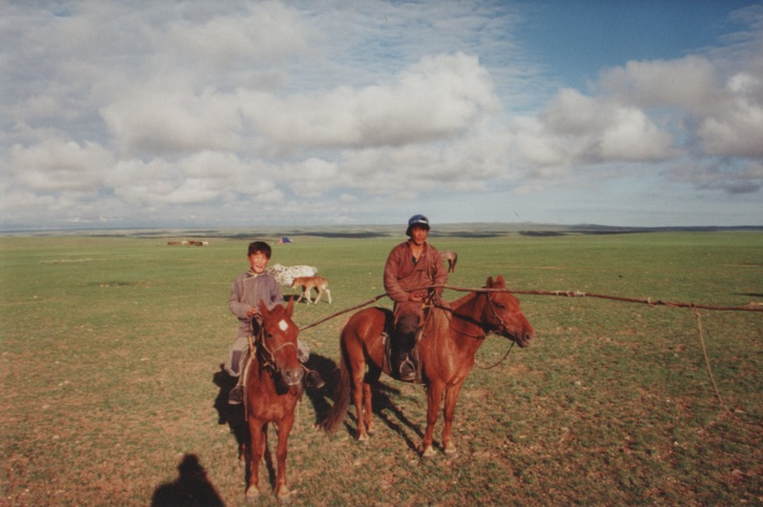

identifier
3184fd83-1278-41d1-931a-0d19b12d4c98

creator
Sneath, David

type
Image

coverage
Govisumber aimag
Mongolia

description

publisher

source
scanned from a photographic print held in the archives of the Mongolia and Inner Asia Studies Unit, University of Cambridge

rights

subject
horses
pastoralism

date
1995

language

format
image/png

contributor

original filename
sneath-govisumber_06.png

relation

extent
1776x1182 px
3.1MiB

