Photograph from Govisumber, No. 03
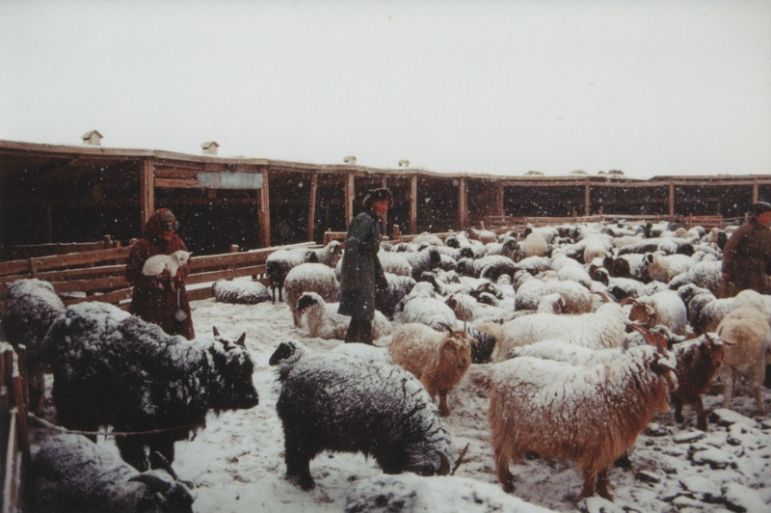

identifier
32d3f16e-d3ff-4fcb-9d1e-779e47ed0c7b

creator
Sneath, David

type
Image

coverage
Govisumber aimag
Mongolia

description

publisher

source
scanned from a photographic print held in the archives of the Mongolia and Inner Asia Studies Unit, University of Cambridge

rights

subject
livestock enclosures
morning activities
pastoral camps

date
1995

language

format
image/png

contributor

original filename
sneath-govisumber_03.png

relation

extent
1776x1182 px
3.2MiB

