Caroline Humphrey Mongolia Super8 film no. 3
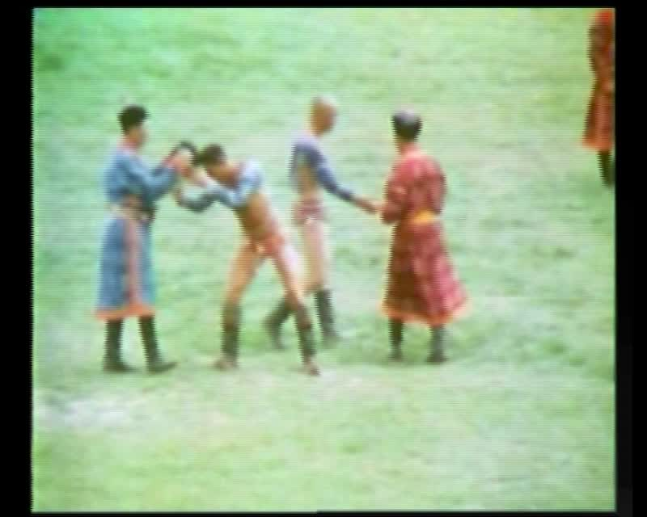

identifier
3c3e3ba3-f02b-489a-9aec-5f58d40749cb

creator
Humphrey, Caroline

type
Moving Image

coverage
Mongolia
Ulaanbaatar

description
Wrestling competition in Ulaanbaatar

publisher
MIASU

source
Digitized from a VCR transfer tape held at the Mongolia and Inner Asia Studies Unit, University of Cambridge

rights
Copyright Caroline Humphrey

subject
Naadam
wrestling

date
ca. 1970s

language
None

original filename
humphrey-super8-mongolia-03.mp4

extent
841.4 MiB
218.347000

alternate url false
https://archive.org/embed/3c3e3ba3-f02b-489a-9aec-5f58d40749cb

format
video/mp4

modified
2017-06-16 09:35:23

