ECCIA work programme, June 1992
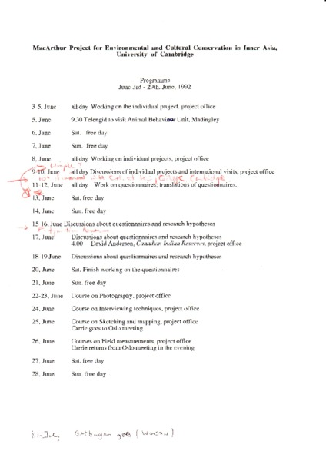

identifier
43e26a1e-b15d-4868-98dc-e2ad4a272409

creator

type
Text

coverage

description

publisher

source
Scanned from an original document held in the archives of the Mongolia and Inner Asia Studies Unit, University of Cambridge.

rights

subject

date
ca. 1992

language

original filename
macarthur-programme-june-1992.pdf

relation

extent
442.4 KiB

contributor

format
application/pdf

modified
2017-05-25 10:49:38

