Yeröö breed rams at a well
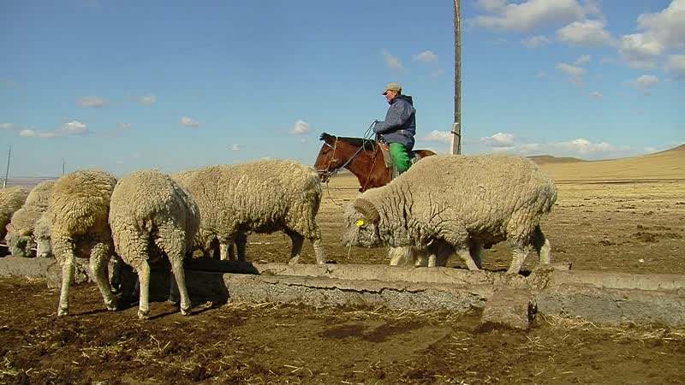

identifier
454c3328-889e-4a25-b766-b313d6fd55a5

creator
Thrift, Eric

type
Moving Image

coverage
Mongolia
Selenge aimag
Yeröö sum

description
This video recording documents rams of the Yeröö breed being watered at a well. The rams are herded together by a single household, which distributes them to households participating in the Yeröö breeding program.

publisher

source

rights

subject
Pastoralism Videos
Yeroo Sheep-Rams
Watering Livestock

date
2012-04-07

language

format
inode/directory

modified
2018-01-17 20:15:05

original filename
PastoralismVideos--2012-04-07--YerooSheep-Rams--WateringLivestock--Selenge-Yeroo.vclips

table of contents
time | clip | description
0:00:00 | 244 0264 01

