Caroline Humphrey - Buryatia photos - No. 24
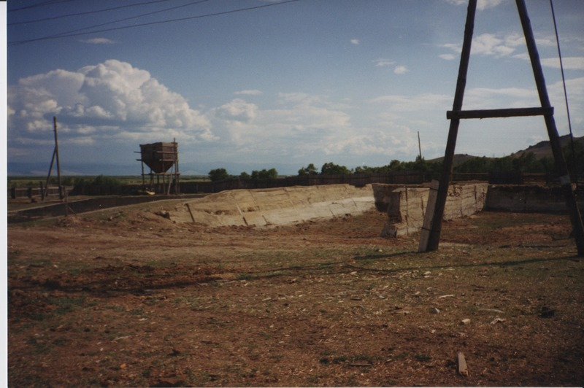

identifier
4559aa41-6fae-40dd-9f5f-2ce450cad4f1

creator
Humphrey, Caroline

type
Image

coverage
Ulung Collective
Buryatia
USSR

description

publisher

source
Scanned from a print held in the archives of the Mongolia and Inner Asia Studies Unit, University of Cambridge.

rights

subject

date
1993-07-25

language

extent
3.3MiB
1799x1196 px

contributor

original filename
Humphrey-Buryatia-photos-24.png

relation

format
image/png

