Caroline Humphrey - Buryatia photos - No. 4-01
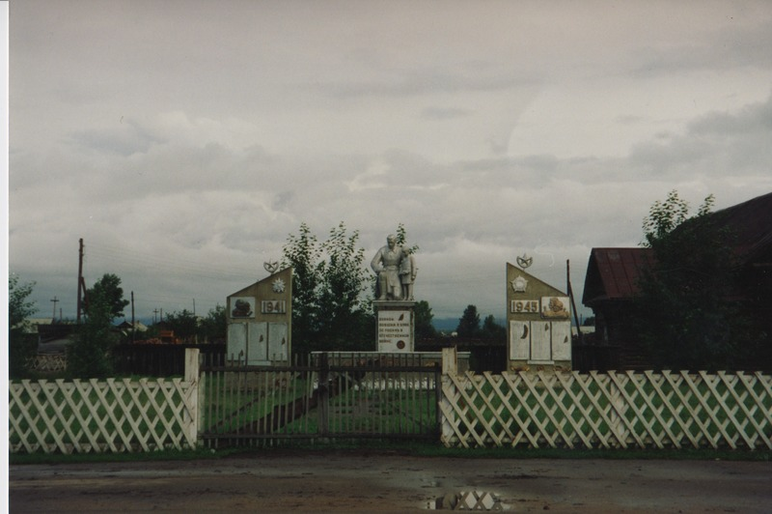

identifier
482c653f-5ee8-4d0e-bbc6-b19988ae646c

creator
Humphrey, Caroline

type
Image

coverage
Uro
Bayangol
Buryatia
USSR

description
Barguzin Station

publisher

source
Scanned from a print held in the archives of the Mongolia and Inner Asia Studies Unit, University of Cambridge.

rights

subject

date
1993

language

contributor

original filename
Humphrey-Buryatia-photos-4-01.png

relation

extent
3.2MiB
1799x1196 px

format
image/png

