Caroline Humphrey - Buryatia photos - No. 4-07
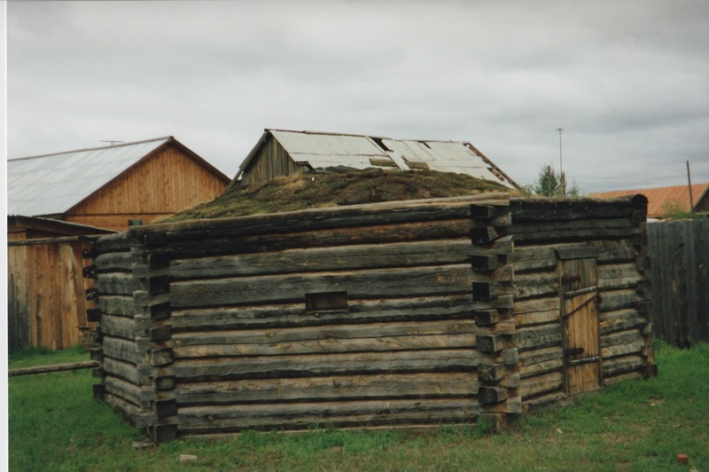

identifier
496b281e-9441-4166-ba1c-d0312da060cc

creator
Humphrey, Caroline

type
Image

coverage
Uro
Bayangol
Buryatia
USSR

description

publisher

source
Scanned from a print held in the archives of the Mongolia and Inner Asia Studies Unit, University of Cambridge.

rights

subject

date
1993

language

extent
3.2MiB
1799x1196 px

contributor

original filename
Humphrey-Buryatia-photos-4-07.png

relation

format
image/png

