David Sneath - photographs from Xingmeng, Yunnan - No. 37
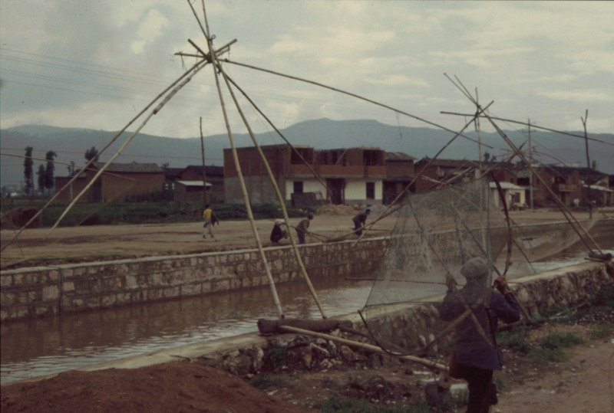

identifier
4caa7506-133b-45f3-8555-e80bd3c2c84b

creator
Sneath, David

type
Image

coverage
PRC
Yunnan

description

publisher

source
Digitized from a 35mm slide provided by the author.

rights

subject

date
1997

language

format
image/tiff

contributor

original filename
David Sneath - photographs from Xingmeng, Yunnan - No. 37.tif

relation

extent
42.6MiB
4704x3168 px

public

