Oral history interview No. 080810B with Sugir (b. 1963): translation
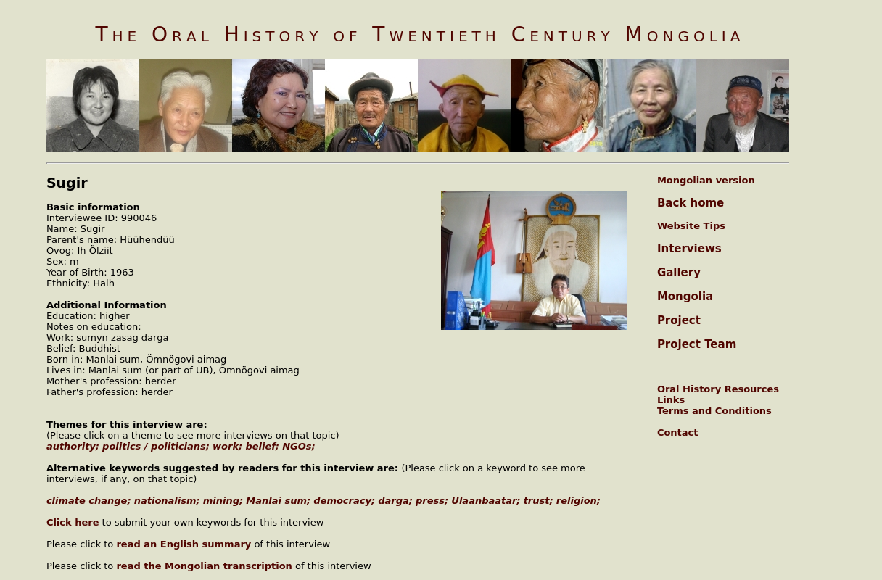

identifier
5299e029-ea96-4afc-8bb9-0618b338aeb7

creator
Sugir

type
Text

coverage
Manlai sum
Mongolia
Ömnögovi aimag

description
In this interview Sugirtai continues to elaborate on the topics of socialism and democracy. In his view, during socialism dargas were in general wise and respected people, they did not have greed as opposed to today’s dargas who use their position to benefit themselves and their families. Today, people lost trust in each other, partly because of the bad influence of the press. Although nobody says that Mongolia should return to socialism, all the negatives things that are happening today, show that democracy is going in the wrong direction. Other topics that Sugirtai mentions in his interview are Ulaanbaatar in the 1980s and Manlai sum. Sugirtai describes himself as a moderate religious man. He thinks that some aspects of Buddhism are useful. However, he despises Christianity as a religion that alienates people from each other. For instance, instead of thanking the person who really helped, a Christian thanks God for sending that person.

publisher
Oral History of Twentieth Century Mongolia

source
<http://amantuuh.socanth.cam.ac.uk/search/view_trans.php?Interview=080810B>

rights
Copyright MIASU. Reproduced with permission. Brief excerpts from interviews and other material may be used in academic or popular work for non-commercial purposes provided proper attribution and credit is given to the Oral History of Twentieth Century Mongolia and the Mongolia and Inner Asia Studies Unit (MIASU). You must not: (a) republish this material (including republication on another website) without the express written permission of MIASU; (b) sell, rent or sub-license material from the website; (c) show any material from the website in public without attribution to The Oral History of Twentieth Century Mongolia; (d) reproduce, duplicate, copy or otherwise exploit material on the website for a commercial purpose without express written permission; (e) use the material in any way that is damaging to the project or any of the persons named in the interviews. See <http://amantuuh.socanth.cam.ac.uk/terms.php> for details.

subject
NGOs
authority
belief
mining
politicians
work

date
2008

language
English

format
text/plain

contributor
Oyuntungalag

original filename
080810B-Sugir-translation.url

relation
7858b6a8-e541-4bf6-ac38-a64d0b18dbea

extent
74.0 B

