Milking camels and taking sheep out to pasture at Zagdsüren's place, Dornogovi
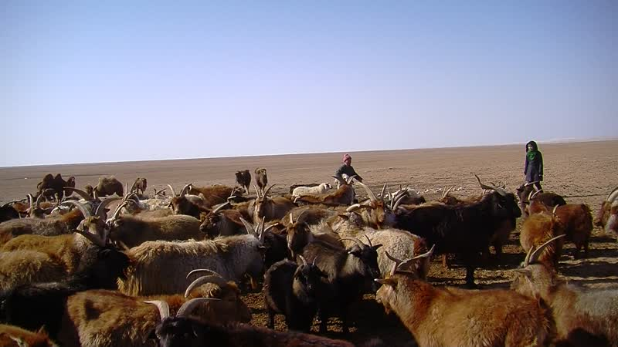

identifier
5838f0dc-f00c-41b7-ac41-5d81fa8090f0

creator
Thrift, Eric

type
Moving Image

coverage
Mongolia
Dornogovi aimag

description
This series of audiovisual recordings depicts the morning activities at Zagdsüren's home in Dornogovi, close to Khamar Monastery. Zagdsüren manages the livestock on her own with her young grandson; her husband and son both live at the Monastery. She milks the camels, discussing the merits of camels over other types of livestock. She shows the camel's "tar" (bokhi), a black substance that is secreted from the back of a male camel's neck when it is in heat, which is used as a medicine to cure cancer-like serious illnesses. Her grandson demonstrates the cloth sack used for carrying lambs that are born at pasture, and shows two newborn lambs that are being kept warm overnight inside the yurt. We follow him as he drives the sheep off to graze.

publisher

source

rights

subject
Pastoralism Videos
Milking Camels
Sheep Grazing
Zagdsuren

date
2012-03-14

language

format
inode/directory

modified
2018-01-17 20:15:05

original filename
PastoralismVideos--2012-03-14--MilkingCamels--SheepGrazing--Zagdsuren--Dornogovi.vclips

table of contents
time | clip | description
0:00:00 | 244 0180 02
0:13:54 | 244 0180 03
0:18:22 | 244 0181 01
0:32:15 | 244 0181 02
0:46:09 | 244 0181 03
0:46:26 | 244 0182 01
0:55:38 | 244 0183 01
0:55:56 | 244 0184 01
0:56:37 | 244 0185 01
0:57:33 | 244 0186 01
0:58:58 | 244 0187 01
0:59:37 | 244 0188 01
1:00:59 | 244 0189 01
1:01:20 | 244 0190 01
1:01:39 | 244 0191 01
1:02:04 | 244 0192 01
1:04:51 | 244 0193 01
1:06:44 | 244 0194 01
1:07:12 | 244 0195 01
1:08:02 | 244 0196 01
1:08:43 | 244 0197 01
1:11:27 | 244 0198 01
1:11:28 | 244 0199 01
1:11:34 | 244 0200 01

