Caroline Humphrey - Buryatia photos - No. 3-09
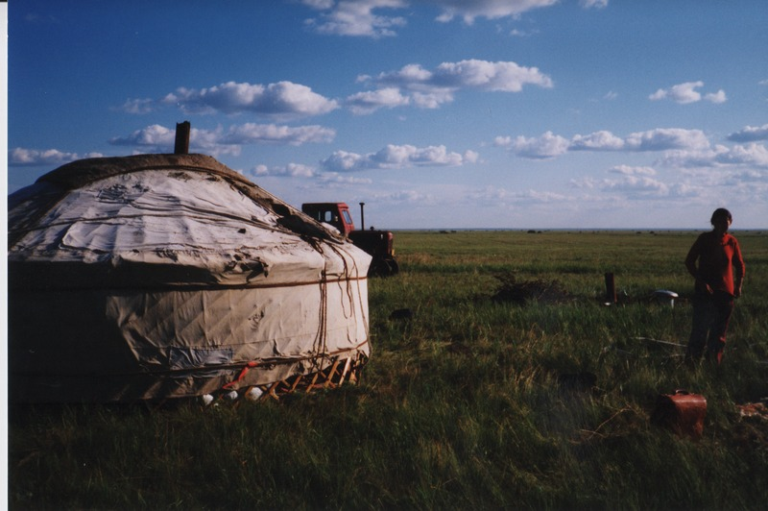

identifier
5bdcddba-0545-4fa1-9520-63b086ae4b9a

creator
Humphrey, Caroline

type
Image

coverage
Khargant

description

publisher

source
Scanned from a print held in the archives of the Mongolia and Inner Asia Studies Unit, University of Cambridge.

rights

subject

date
1993

language

extent
3.3MiB
1799x1196 px

contributor

original filename
Humphrey-Buryatia-photos-3-09.png

relation

format
image/png

