Visit with Mendee and his brothers - Yeröö
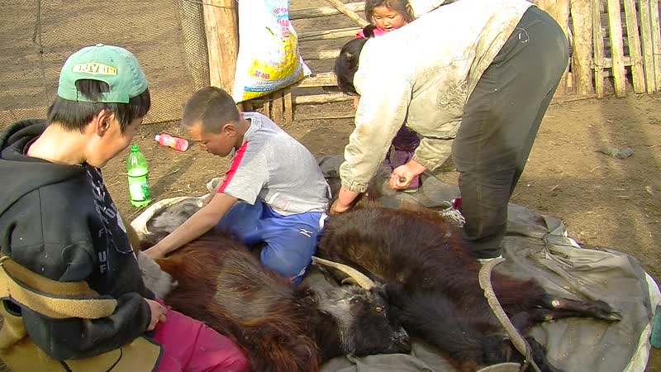

identifier
68f2a88c-3c9b-4899-9ff1-421b6c7245cf

creator
Thrift, Eric

type
Moving Image

coverage
Mongolia
Selenge aimag
Yeröö sum

description
This series of audiovisual recordings documents activities at Tasag in Yeröö sum, Selenge aimag. We first visit Mendee, who feeds his pigs and chickens, then takes us to see the stump of a tree that was knocked down by lightning in the nearby pasture. Mendee, his son and nephews load plastic barrels onto the back of their truck and drive over to the creek, about 300 metres from their home, to get water for the vegetable garden. Next we drive down the road to Mendee's brother Bat-Erdene's home, where his wife is busy combing goats. Afterwards we visit another brother, Batsaikhan, who brings the sheep and goats into the livestock pen as it begins to get dark. Batsaikhan talks about his experiences growing up in a family of Buryat herders working for the former State Farm, and his efforts to keep Yeröö sheep, which he is cross-breeding with local sheep breeds.

publisher

source

rights

subject
Pastoralism Videos
Feeding Pigs
Feeding Chickens
Fetching Water
Combing Goats
Evening Activities
Mendee-Bat-Erdene-Batsaikhan

date
2012-04-21

language

format
inode/directory

modified
2018-01-18 10:46:11

original filename
PastoralismVideos--2012-04-21--FeedingPigs--FeedingChickens--FetchingWater--CombingGoats--EveningActivities--Mendee-Bat-Erdene-Batsaikhan--Selenge-Yeroo.vclips

table of contents
time | clip | description
0:00:00 | 244 0289 01 | Visit with Mendee
0:13:54 | 244 0289 02
0:16:48 | 244 0290 01
0:18:27 | 244 0291 01
0:19:09 | 244 0292 01
0:33:03 | 244 0292 02
0:46:22 | 244 0293 01
1:00:17 | 244 0293 02
1:13:19 | 244 0294 01
1:27:13 | 244 0294 02
1:40:25 | 244 0295 01
1:52:49 | 244 0295 02
2:00:51 | 244 0296 01
2:14:45 | 244 0296 02

