Caroline Humphrey - Buryatia photos - No. 06
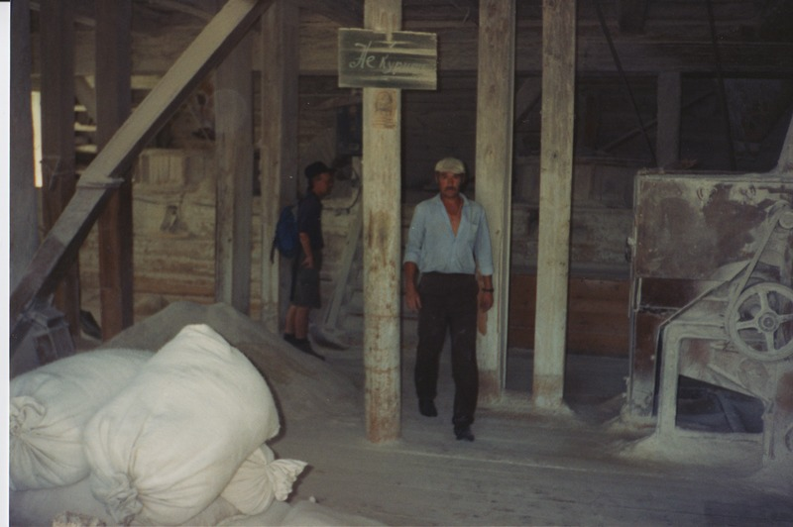

identifier
6e008dbc-e3e2-4892-9259-0509ef88358d

creator
Humphrey, Caroline

type
Image

coverage
Ulung Collective
Buryatia
USSR

description

publisher

source
Scanned from a print held in the archives of the Mongolia and Inner Asia Studies Unit, University of Cambridge.

rights

subject

date
1993-07-25

language

extent
3.2MiB
1799x1196 px

contributor

original filename
Humphrey-Buryatia-photos-06.png

relation

format
image/png

