Notes on mountain worship practices in Hoboksair
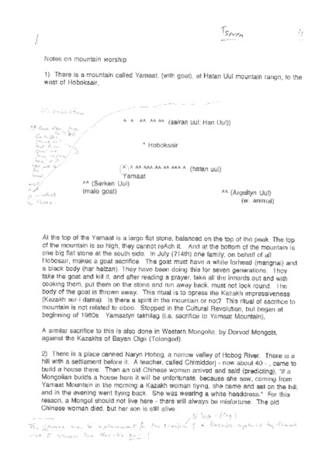

identifier
7053a7ea-fef6-44bc-8952-2ca82dca1625

creator
Tseren, BP

type
Text

coverage
PRC
Xinjiang
Hoboksair

description

publisher

source
Scanned from an original document held in the archives of the Mongolia and Inner Asia Studies Unit, University of Cambridge.

rights

subject
ovoo
mountain worship

date
ca. 1992

language
English

original filename
tseren-notes-on-mountain-worship.pdf

relation

extent
1.4 MiB

contributor

format
application/pdf

modified
2017-05-29 12:12:49

