“Гоё тараг”, “Зөв аарцны ундаа” Хятадад савлагдаж байна уу?
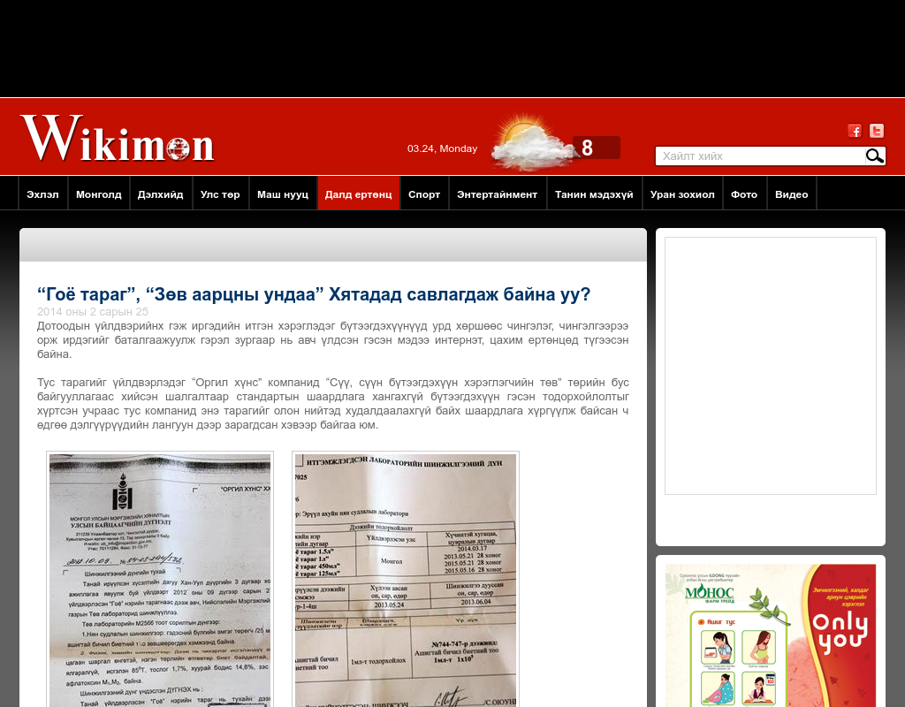

identifier
74e48bba-760c-47e8-ae28-4a5f1dacf94d

creator

type
Text

coverage
Mongolia

description

publisher

source
http://www.wikimon.mn/content/53065.shtml

rights

subject
Mongolia
dairy
nationalism
social media

date
24 Mar 2014 14:37:37

language
Mongolian

format
text/plain

modified
2018-01-11 14:12:43

original filename
wikimon.mn.Goyo_tarag.url

extent
41.0 B

