Image published in “Perestroika and the Pastoralists”
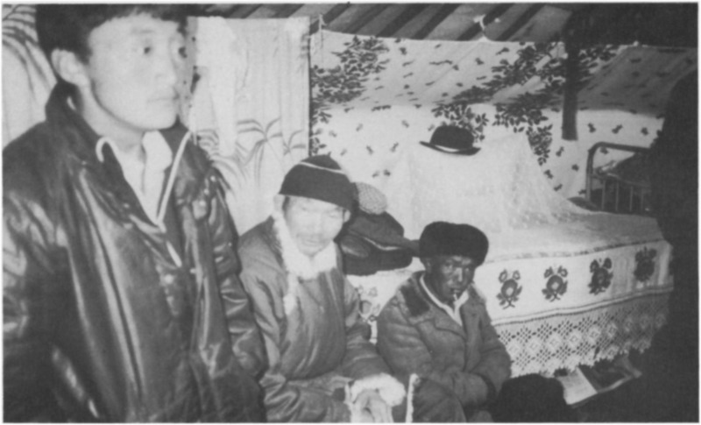

identifier
75ef95a2-9662-4d91-9bd3-2cdc2ce2b3b0

creator
Humphrey, Caroline

type
Image

coverage
Tuva
USSR

description
Herdsmen at a brigade meeting to confirm winter pastures.

publisher
Anthropology Today

source
<https://www.jstor.org/stable/3032697>
Anthropology Today, vol. 5 no. 3, pp. 6--10

rights

subject

date
2017-05-22 11:56:58

language

format
image/png

original filename
at-article-figure_1.png

extent
1777x1077 px
995.4 KiB

