Тэсо ХХК - Милко - Тослог сүү
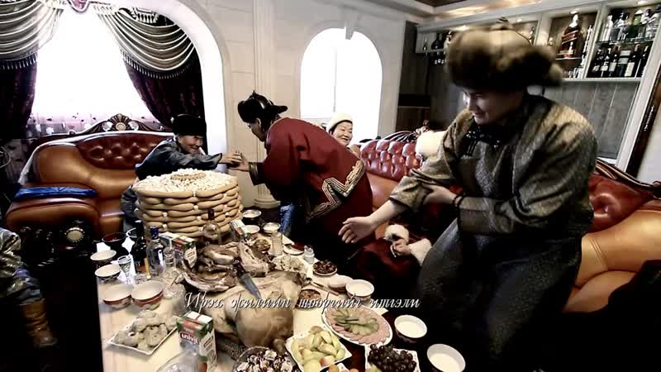

identifier
78579fe4-1260-4718-904b-ffd8f020ab7f

creator
TESO LLC

type
Moving Image

coverage

description
TV commercial for Teso high-fat milk

publisher

source
<http://youtu.be/LoKym6u9t70>

rights

subject
Mongolia
Dairy Production
Milk Marketing
Television Commercials

date
2011-03-24 14:00:36

language

format
video/mp4

modified
2014-02-04 01:55:34

extent
7.1 MiB
19.520000

