Caroline Humphrey - Buryatia photos - No. 3-01
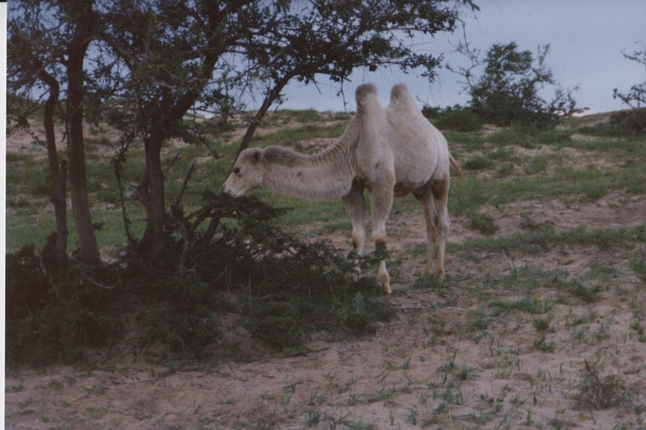

identifier
7d03b99f-d45f-427c-90ad-36551d771eef

creator
Humphrey, Caroline

type
Image

coverage
Khargant

description
Camel eating vegetation.

publisher

source
Scanned from a print held in the archives of the Mongolia and Inner Asia Studies Unit, University of Cambridge.

rights

subject

date
1993

language

contributor

original filename
Humphrey-Buryatia-photos-3-01.png

relation

extent
3.4MiB
1799x1196 px

format
image/png

