Introduction: The concept of Inner Asia
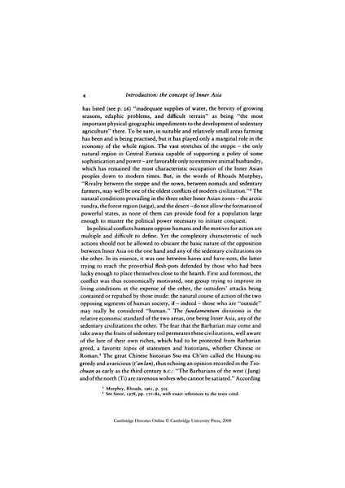

identifier
8796db86-b526-4e7c-bcdf-d8f025ed82f6

creator
Sinor, Denis

type
Text

coverage
Inner Asia

description
If the continents of Europe and Asia are conceptual entities, Eurasia - the combined land mass of the two - is a physiogeographical one. Each of the sedentary civilizations - in loose terminology Europe, the Middle East, India, Southeast Asia and East Asia - is a unique combination of cultural features. Some of these may appear in more than one area; yet an association of various components, moulded by a unique historical process and greatly influenced by national environment, made each of these regions different from the others. The frontier of Inner Asia is unstable; it has varied from age to age, shifting according to the balance of power between its own population and that of the surrounding, sedentary civilizations. The military efficiency of a nomad cavalry force was a function of its size, but the relationship between the number of horses and their military value was not a mathematical constant but a geometric progression.

publisher
Cambridge University Press

source
<https://doi.org/10.1017/CHOL9780521243049.002>
Sinor, Denis, ed. The Cambridge history of early Inner Asia. Vol. 1. Cambridge University Press, 1990.

rights
Copyright Cambridge University Press

subject
Inner Asia
cultural ecology
history

date
1990

language
English

original filename
Sinor1990.pdf

extent
1.4 MiB

format
application/pdf

modified
2013-02-06 05:48:29

