Photograph from Govisumber, No. 11
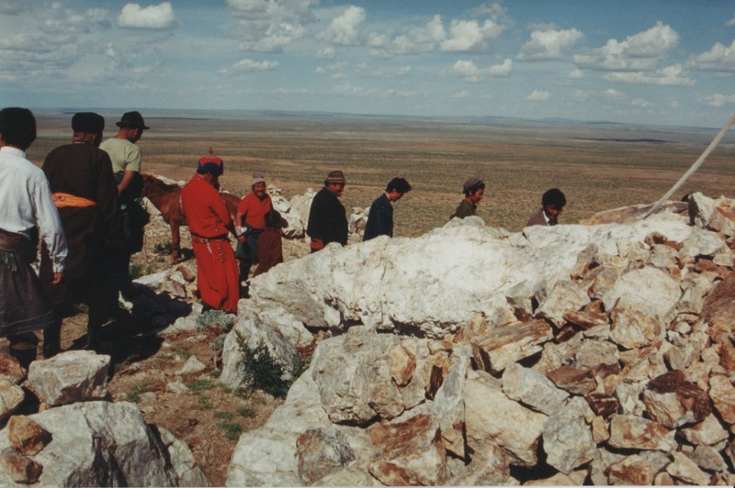

identifier
8a4d2f65-00dd-4f80-b4d6-1be66ff2ad98

creator
Sneath, David

type
Image

coverage
Govisumber aimag
Mongolia

description

publisher

source
scanned from a photographic print held in the archives of the Mongolia and Inner Asia Studies Unit, University of Cambridge

rights

subject
ovoo

date
1995

language

format
image/png

contributor

original filename
sneath-govisumber_11.png

relation

extent
1776x1182 px
3.3MiB

