Nomin and Oyunaa on otor in Erdene sum: Making khuruud, shearing sheep, and castrating sheep and goats
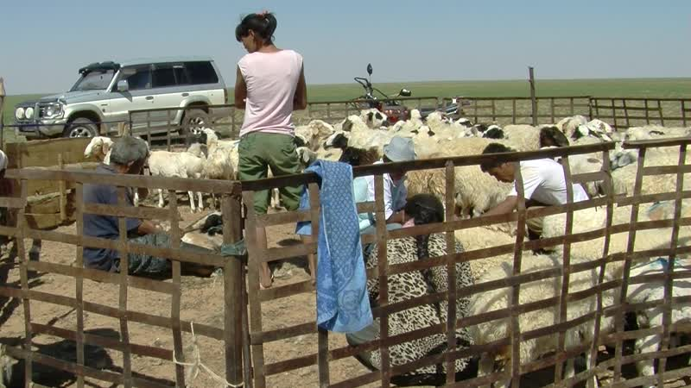

identifier
8c2115a2-c409-4188-be6b-4d7550e62222

creator
Thrift, Eric

type
Moving Image

coverage
Mongolia

description
The recordings in this series depict a variety of activities among families at their otor camps in Erdene sum, Dornogovi aimag. The first clips show cutting khuruud and milking goats at Nomin and Oyunaa's place. The next clips were taken as we visited a family in the neighbouring camp who were shearing sheep. We then returned to Nomin and Oyunaa's place where Sodnomtsog castrated the family's sheep and goats. The final clip shows us getting water from a well and pouring it into a trough for the livestock.

publisher

source

rights

subject
Pastoralism Videos
Castrating Sheep Goats
Making Khuruud
Milking Goats
Watering Livestock
Nomin-Oyunaa
Shearing Sheep
Watering Livestock

date
2012-07-01

language

format
inode/directory

modified
2018-03-02 09:37:44

original filename
PastoralismVideos--2012-07-01--CastratingSheepGoats--MakingKhuruud--MilkingGoats--WateringLivestock--Nomin-Oyunaa--ShearingSheep--WateringLivestock.vclips

table of contents
time | clip | description
0:00:00 | 300G0010 01 | Dolgor takes a sack of curds that have been drained and pressed, and holding it in her lap, begins slicing the curd into khuruud. She placed the sliced curds on a tray next to her on the floor. Her granddaughter comes over, sits on her legs for a moment, then leaves with a bottle of cola. Nomin comes over, bringing a new tray, and removes the first one which is now full of curds. As Dolgor continues cutting the curds, Nomin takes the first tray outside and places it on the roof of the yurt so the curds can dry in the sun.
0:08:58 | 300G0011 01 | Nomin, Ider, Sodnomtsog, and Ider's nephew and niece separate the goats to be milked from the rest of the herd. They chase after several stray goats, and drive the males away to graze. As Dolgor and Oyunaa get ready to milk the goats, Ider and Nomin bring them next to the pen.
0:22:51 | 300G0011 02 | As Nomin gets ready to drive the goats into the pen, a goat escapes and Oyunaa chases after it. Finally Nomin and Ider get the goats into the pen. Sodnomtsog stands by watching. Oyunaa begins milking the goats. Nomin goes back to the yurt, gets on his motorcycle, and rides off with his nephew sitting on the back.
0:29:08 | 300G0012 01 | Ider stands at the gate of the goat pen, letting out the milked goats, as Oyunaa continues milking. After about ten minutes Dolgor enters the pen with an empty pail and joins in the milking.
0:43:02 | 300G0012 02 | Dolgor and Oyunaa continue milking the goats. Oyunaa's takes her full pail out of the pen, pours it through a cheesecloth into a metal container, then returns to the milking. The boy returns on horseback; Ider hitches the horse to the post of the pen.
0:56:55 | 300G0012 03 | Dolgor and Oyunaa continue milking the goats. Dolgor comes out of the pen and empties her pail. Sodnomtsog has found some dung beetles, and brings Eric to look at them with the camera; then back to the milking.
1:10:49 | 300G0013 01 | This is a family at an otor in Erdene, neighbours of Dorjsuren, who took us to photograph them shearing sheep. The family are shearing sheep. Eric tries shearing a sheep for about five minutes, as Dorjsuren gives instructions.
1:24:43 | 300G0013 02 | Shearing continues.
1:38:36 | 300G0013 03 | Shearing continues.
1:50:49 | 300G0013 04 | Shearing continues.
2:00:42 | 300G0014 01 | Castrating sheep and goats at Nomin and Oyunaa's place. Dorjsuren sits at the back of Nomin and Oyunaa's yurt, drinking tea. Oyunaa stands next to a pot of burning fat and dung on top of the stove. Dorjsuren describes some of the ritual elements associated with the castration of livestock, namely the use of burnng dung (khinshüü), a pole or post from the yurt, and a felt pad. Oyunaa instructs her niece to carry the pot outside; everyone goes out. Sodnomtsog is castrating the livestock seated on a felt roll laid on the ground next to the pen, with the burning fat and dung nearby, as Nomin holds each animal down. Ider brings each animal over to be castrated. Sodnomtsog places the testicles in a bucket (of milk???) next to him on the ground.
2:14:36 | 300G0014 02 | The castrating continues for about ten minutes. Everyone gets up to look for a goat that got away earlier.
2:28:29 | 300G0014 03 | The last goat is found and castrated. Ider's niece carries off the burning dung, while Nomin takes the felt pad, pole, and ties. Ider's nephew carries the bucket of testicles indoors, as everyone follows.
2:31:37 | 300G0015 01 | Dolgor pours the contents of the bucket containing the goats' testicles into an empty pot on top of the stove.
2:32:13 | 300G0016 01 | The testicles are cooked; Oyunaa takes the pot off the stove and sets it on top of the fuel box. She ladles out the testicles into small bowls and passes them out. Everyone eats.
2:35:38 | 300G0017 01 | Ider draws water from the well and pours it into the trough for watering the goats. Eric draws some water as Dorjsuren gives advice on the best way to do so. Ider resumes drawing water.

