Photograph from Inner Mongolia, No. 06
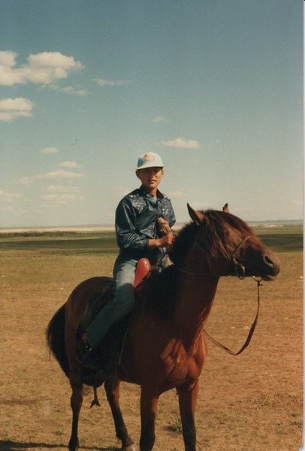

identifier
9e9f2816-c922-40c4-90cb-4cc562e0600f

creator
Sneath, David

type
Image

coverage
Inner Mongolia
PRC

description
Child on horseback

publisher

source
Scanned from a photographic print held in the archives of the Mongolia and Inner Asia Studies Unit, University of Cambridge.

rights

subject
herder households

date
ca. 1988

language

original filename
sneath-inner-mongolia-1980s.png_06.png

relation

extent
3.0 MiB
1182x1747 px

contributor

format
image/png

modified
2017-05-25 11:00:20

