Caroline Humphrey interview transcript
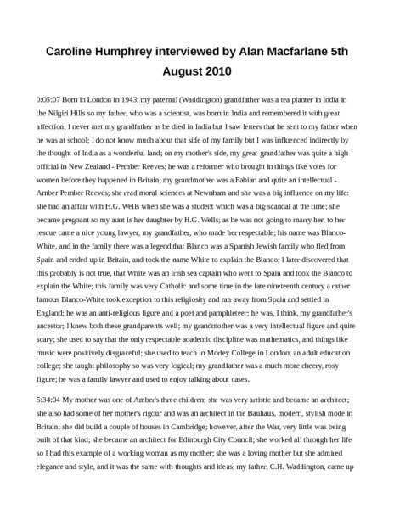

identifier
a1eeba54-c798-4f2f-84d7-68d3a3f56b11

creator
Humphrey, Caroline

type
Text

coverage
Buryatia
Russia
USSR

description
Caroline Humphrey interviewed by Alan Macfarlane on 5th August 2010

publisher

source
MIASU

rights

subject

date
2017-05-25 10:38:05

language

extent
38.5KiB

contributor
Macfarlane, Alan

original filename
Caroline-Humphrey-interview-transcript.docx

relation

format

