Caroline Humphrey - Buryatia photos - No. 2-05
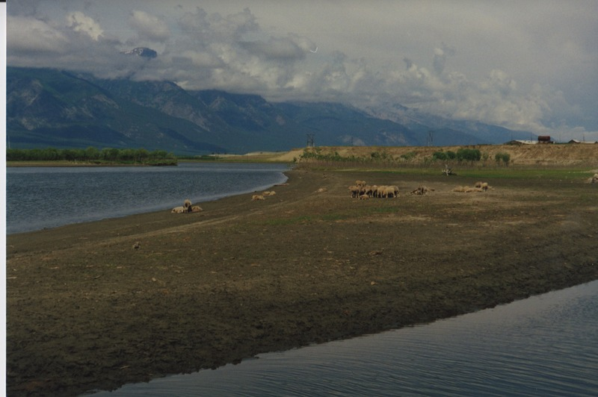

identifier
a52d94a9-2346-4940-9c98-9df1398e91ef

creator
Humphrey, Caroline

type
Image

coverage
Bayangol
Khilgana
Karl Marx Collective
Buryatia
USSR

description

publisher

source
Scanned from a print held in the archives of the Mongolia and Inner Asia Studies Unit, University of Cambridge.

rights

subject

date
1993

language

extent
3.2MiB
1799x1196 px

contributor

original filename
Humphrey-Buryatia-photos-2-05.png

relation

format
image/png

