Photographs from Barguzin, No. 01
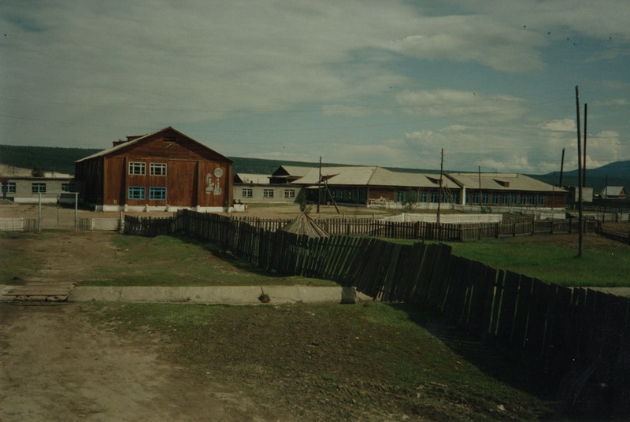

identifier
a73fd0f2-5952-448b-897c-615ea6e26481

creator
Gomboev, Bair

type
Image

coverage
Barguzin
Burtyatia
Russian Federation

description
Argada village -- local middle school

date
1993-07

language

format
image/png

modified
2017-05-25 01:56:06

original filename
bair-batbuyan-photos-01.png

source
Scanned from a photographic print held in the archives of the Mongolia and Inner Asia Studies Unit, University of Cambridge

extent
3.3 MiB
1777x1191 px

subject
schools

