The collective farms after Socialism
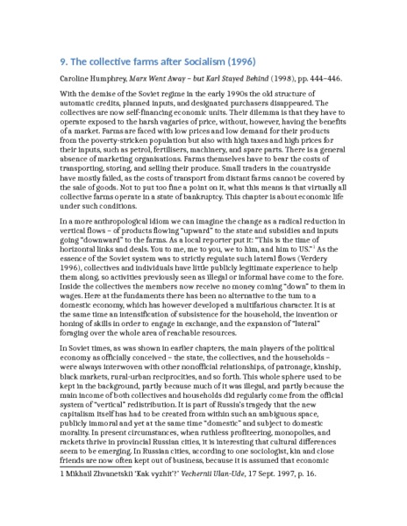

identifier
c2b96d9c-5f3a-49d9-950d-7cf44caf7f20

creator
Humphrey, Caroline

type
Text

coverage
Ulung Collective
Buryatia
USSR

description
Extract from “Karl Marx Collective”.

publisher

source
Caroline Humphrey, Marx Went Away – but Karl Stayed Behind (1998), pp. 444–446.

rights

subject

date
2017-05-26 05:24:25

language
English

contributor

original filename
ch-9-extract.docx

relation

extent
12.5KiB

format

