1941507. Batyr Elistaev, Mandala Offering
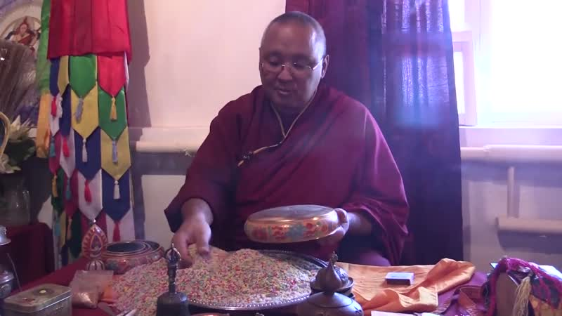

identifier
c38d18b9-a635-49e0-b1a9-f33c3e825f9c

creator
Kalmyk Cultural Heritage Documentation Project

type
Moving Image

coverage
Kalmykia
Russia

description

publisher
University of Cambridge

source
<http://www.kalmykheritage.socanth.cam.ac.uk>

rights
Copyright Kalmyk Cultural Heritage Documentation Project. Licensed under a Creative Commons BY-NC-ND Unported license.

subject
Buddhism
Kalmyks

date
2015-06-15 09:48:45

language

extent
120.2 MiB
321.520000

format
video/mp4

modified
2017-05-27 10:45:44

original filename
1941516.mp4

remote embed url
http://sms.cam.ac.uk/media/1941507/embed

public
FALSE

