Путешествия Г.Н. Потанина по Китаю, Тибету и Монголии [Travels of GN Potanin in China, Tibet, and Mongolia]
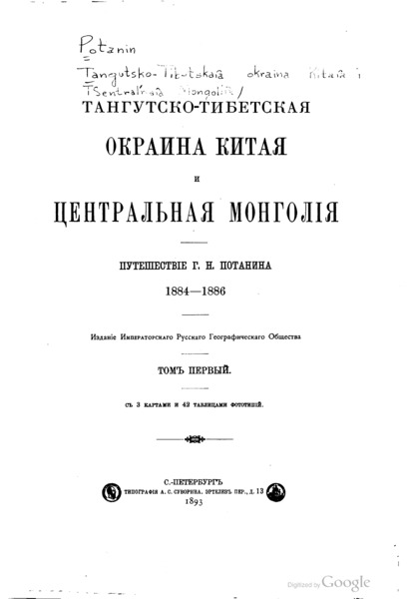

identifier
c84bcc22-889f-4326-9a16-3572de8d0ae1

creator
Potanin, GN

type
Text

coverage
Mongolia
PRC
Tibet

description
Grigory Potanin was a Russian ethnographer and natural historian, whose work concerned Mongolian and Uighur language and culture.

publisher

source
Google Books

rights
Public domain

subject
expeditions

date
1893

language
Russian

format
application/pdf

modified
2017-10-09 13:33:51

original filename
Tangutsko_Tibetskaia_okraina_Kitaia.pdf

extent
54.0 MiB

