Caroline Humphrey - Buryatia photos - No. 18
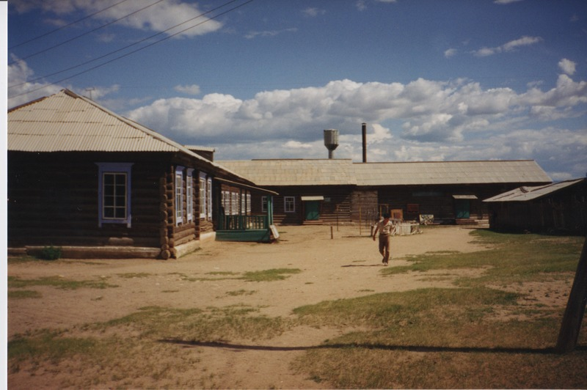

identifier
c98a725a-9638-4289-8571-763897725ca4

creator
Humphrey, Caroline

type
Image

coverage
Ulung Collective
Buryatia
USSR

description
School.

publisher

source
Scanned from a print held in the archives of the Mongolia and Inner Asia Studies Unit, University of Cambridge.

rights

subject

date
1993-07-25

language

contributor

original filename
Humphrey-Buryatia-photos-18.png

relation

extent
3.3MiB
1799x1196 px

format
image/png

