Caroline Humphrey - Buryatia photos - No. 07
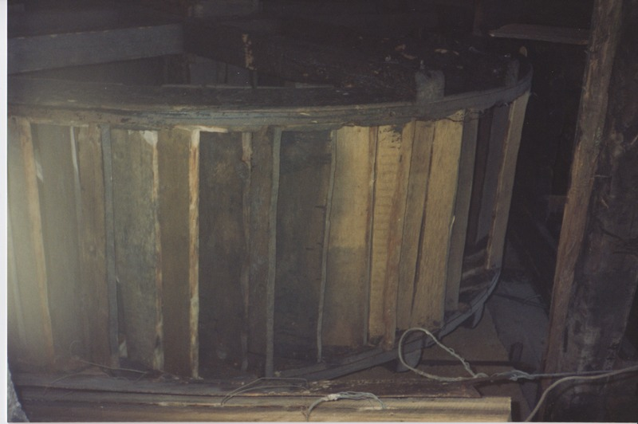

identifier
d8d2e174-576e-4712-85a8-ffc4cc597161

creator
Humphrey, Caroline

type
Image

coverage
Ulung Collective
Buryatia
USSR

description

publisher

source
Scanned from a print held in the archives of the Mongolia and Inner Asia Studies Unit, University of Cambridge.

rights

subject

date
1993-07-25

language

extent
3.2MiB
1799x1196 px

contributor

original filename
Humphrey-Buryatia-photos-07.png

relation

format
image/png

