Caroline Humphrey - Buryatia photos - No. 2-22
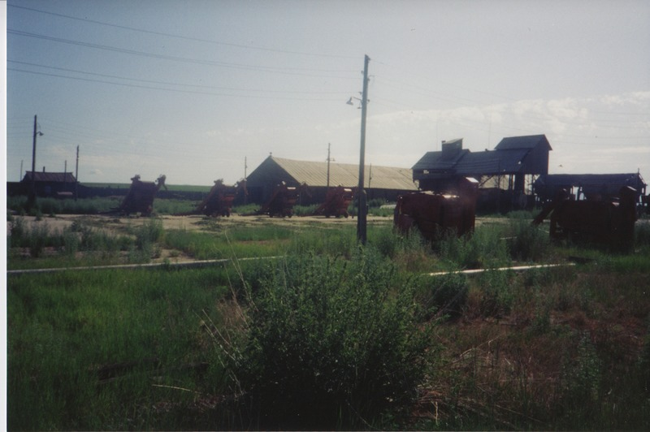

identifier
dcd6681f-3423-4a64-b9c7-64f53ac8dd4a

creator
Humphrey, Caroline

type
Image

coverage
Bayangol
Khilgana
Karl Marx Collective
Buryatia
USSR

description
Farm machinery.

publisher

source
Scanned from a print held in the archives of the Mongolia and Inner Asia Studies Unit, University of Cambridge.

rights

subject

date
1993

language

contributor

original filename
Humphrey-Buryatia-photos-2-22.png

relation

extent
3.1MiB
1799x1196 px

format
image/png

