Oral history interview No. 090744B with Osor (b. 1955): transcript
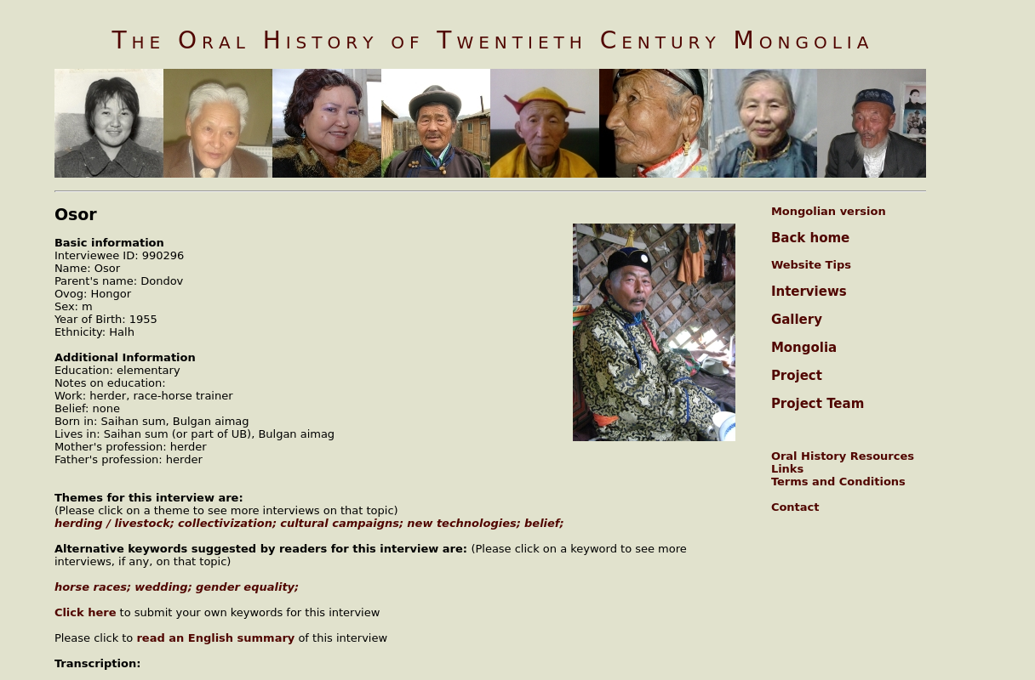

identifier
dd6e48dc-67b2-4791-b3d4-4761bab0ce76

creator
Osor

type
Text

coverage

description

publisher
Oral History of Twentieth Century Mongolia

source
<http://amantuuh.socanth.cam.ac.uk/search/view_transcript.php?Interview=090744B>

rights
Copyright MIASU. Reproduced with permission. Brief excerpts from interviews and other material may be used in academic or popular work for non-commercial purposes provided proper attribution and credit is given to the Oral History of Twentieth Century Mongolia and the Mongolia and Inner Asia Studies Unit (MIASU). You must not: (a) republish this material (including republication on another website) without the express written permission of MIASU; (b) sell, rent or sub-license material from the website; (c) show any material from the website in public without attribution to The Oral History of Twentieth Century Mongolia; (d) reproduce, duplicate, copy or otherwise exploit material on the website for a commercial purpose without express written permission; (e) use the material in any way that is damaging to the project or any of the persons named in the interviews. See <http://amantuuh.socanth.cam.ac.uk/terms.php> for details.

subject

date
2009

language
Mongolian

format
text/plain

contributor
Khishigsüren

original filename
090744B-Osor-transcript.url

relation
21786dd4-aee6-4e8e-b53b-bbe42bb0fad5

extent
79.0 B

