Caroline Humphrey - Buryatia photos - No. 2-18
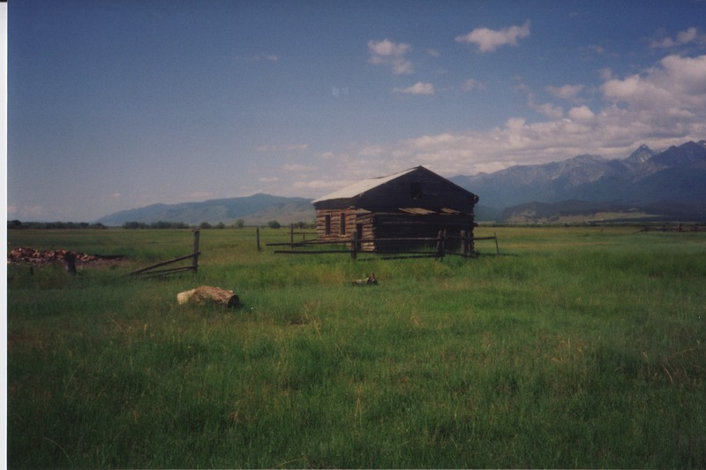

identifier
df6edd06-0f81-4181-a47f-4493cad1c26f

creator
Humphrey, Caroline

type
Image

coverage
Bayangol
Khilgana
Karl Marx Collective
Buryatia
USSR

description
Prairie farmer’s summer camp.

publisher

source
Scanned from a print held in the archives of the Mongolia and Inner Asia Studies Unit, University of Cambridge.

rights

subject

date
1993

language

contributor

original filename
Humphrey-Buryatia-photos-2-18.png

relation

extent
3.2MiB
1799x1196 px

format
image/png

