Photographs from Barguzin, No. 05
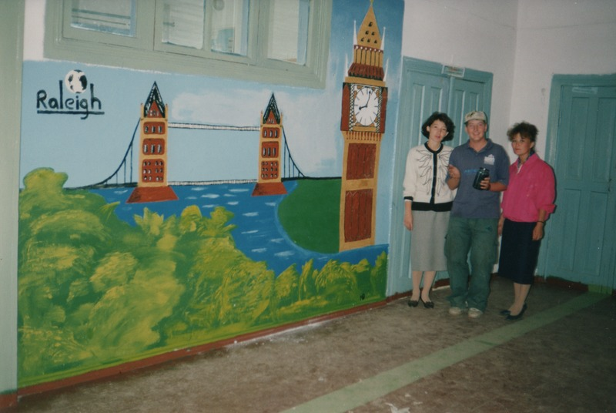

identifier
f2614a22-265e-4c98-b6f2-42d13d0566f7

creator
Gomboev, Bair

type
Image

coverage
Barguzin
Burtyatia
Russian Federation

description
Argada village, Buryatia. Local middle school. Young man from Raleigh International with teachers.

date
1993-08

language

format
image/png

modified
2017-05-25 02:00:28

original filename
bair-batbuyan-photos-05.png

source
Scanned from a photographic print held in the archives of the Mongolia and Inner Asia Studies Unit, University of Cambridge

extent
3.1 MiB
1777x1191 px

subject
Raleigh International
schools

