Caroline Humphrey - Buryatia photos - No. 08
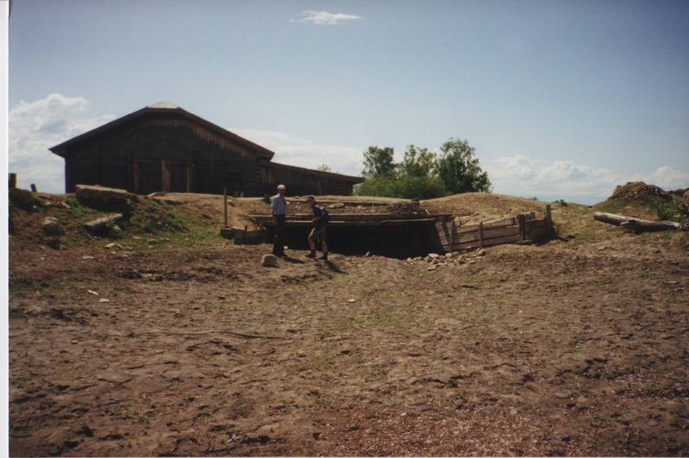

identifier
f7567150-b354-4865-8cb3-b2b6ae8fb8b7

creator
Humphrey, Caroline

type
Image

coverage
Ulung Collective
Buryatia
USSR

description

publisher

source
Scanned from a print held in the archives of the Mongolia and Inner Asia Studies Unit, University of Cambridge.

rights

subject

date
1993-07-25

language

extent
3.3MiB
1799x1196 px

contributor

original filename
Humphrey-Buryatia-photos-08.png

relation

format
image/png

