Kinship terminology of the Barguzin Buryats, 1967
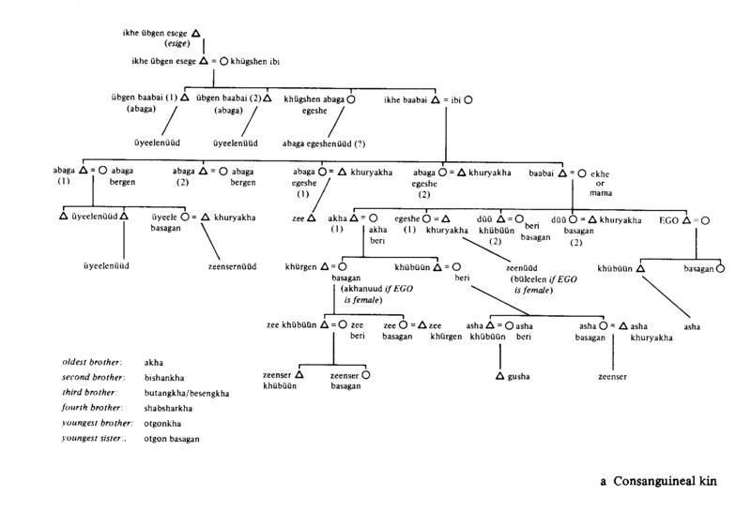

identifier
fe51f760-84e0-484b-8f51-bc737808c37e

creator
Humphrey, Caroline

type
Image

coverage
USSR
Buryatia

description
Consanguineal kin

publisher

source
Karl Marx Collective

rights

subject

date

language
Buryat
English

contributor

original filename
kinship-diagram-0.png

relation

extent
35.7KiB
1905x2786 px

format
image/png

